**Capstone Project - Blog Tracker Application**

**DESCRIPTION**

Basics of C#, MS-SQL Server, ASP.Net MVC, Web API, and NUnit

****Case Study:****

Simplona Tech Solutions needs a full stack ****Blog Tracker Application (BTA)**** to maintain blog details written by their employees as part of the continuous learning process. The employee must write one blog per week and add blog-related information like the blog title, subject, date of creation, and blog URL in the Blog Tracker Application. You need to create a Full Stack Application that allows employees to add their blog-related details and show all blogs written by employees on the home page

**Code:**

**Code is in SourceCode file or github:**

**<https://github.com/SahidAliKhan/Blog-Tracker-App>**

**Output:**

**Azure SQL DB:**

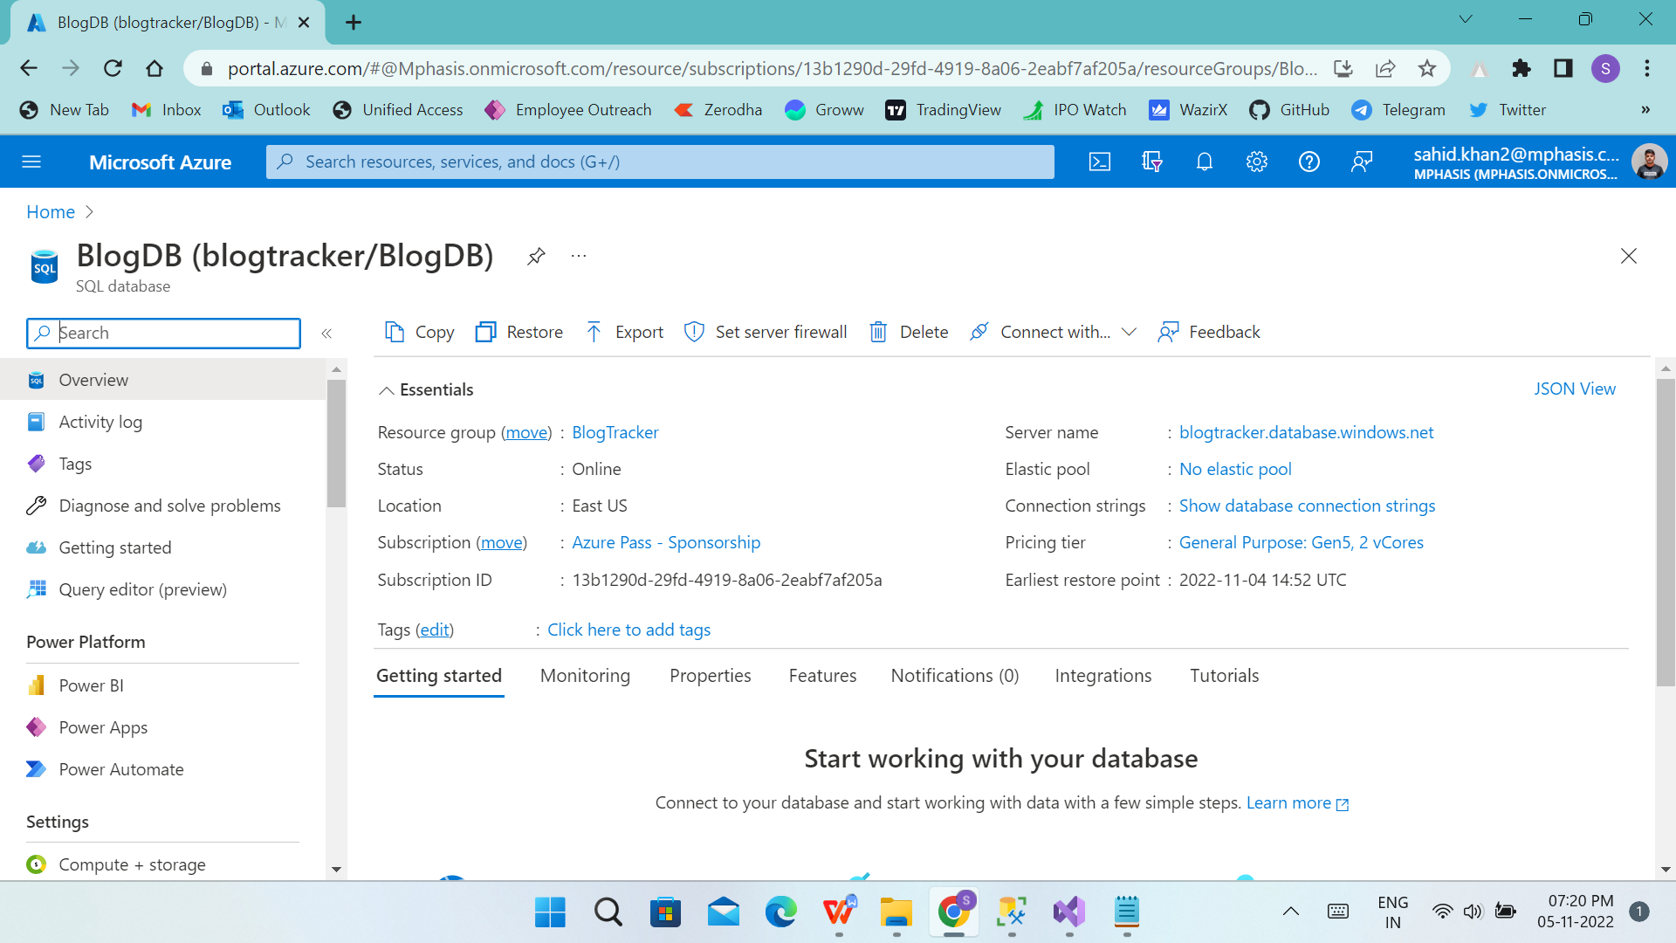

**SSMS:**

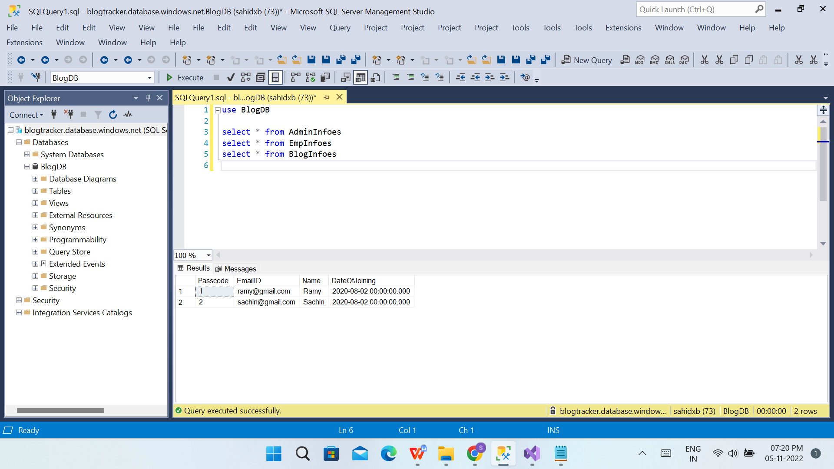

**Visual Studio:**

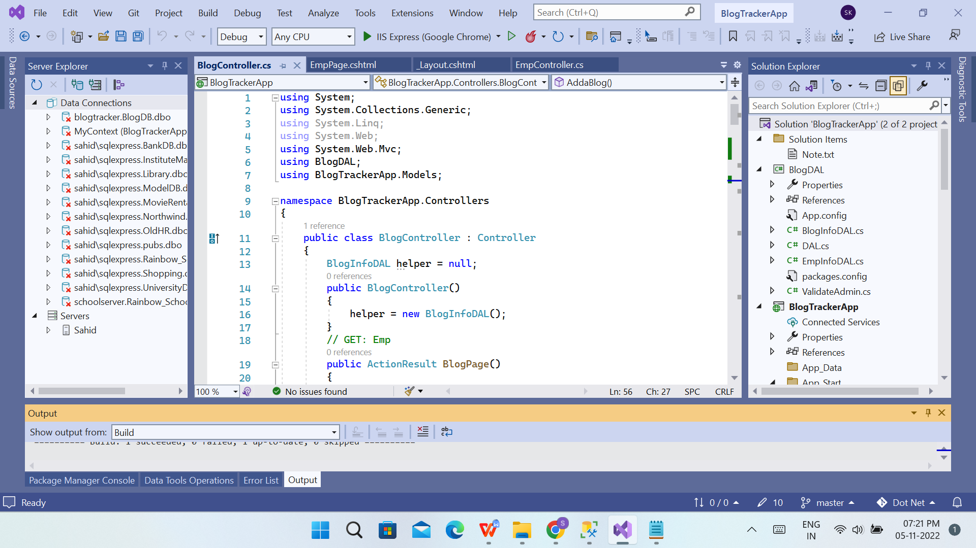

**WebAPI:**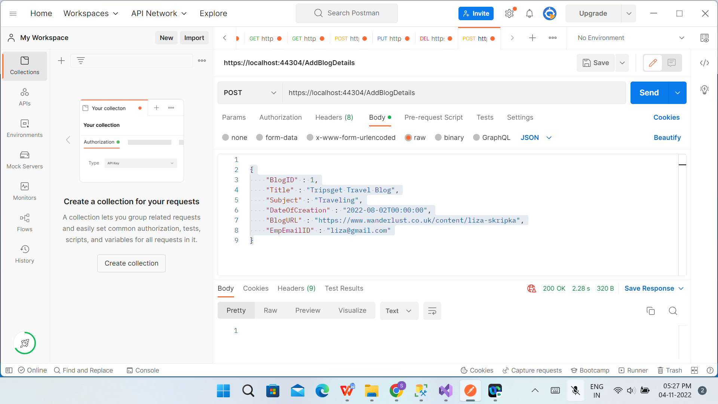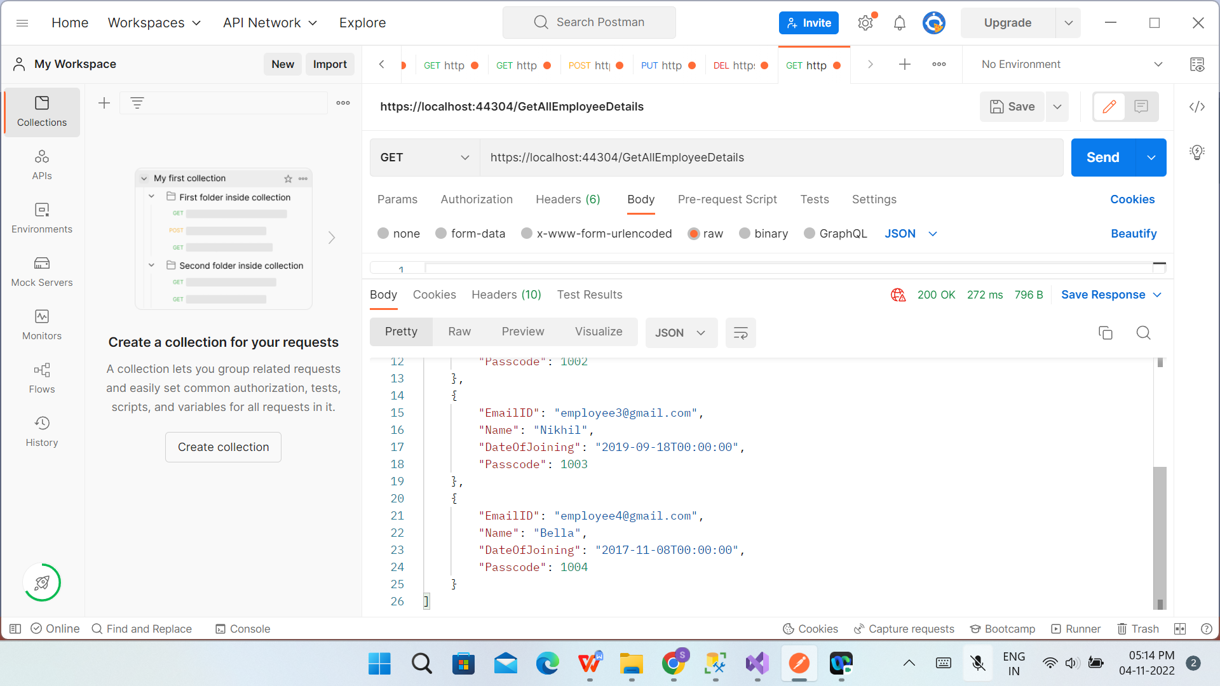

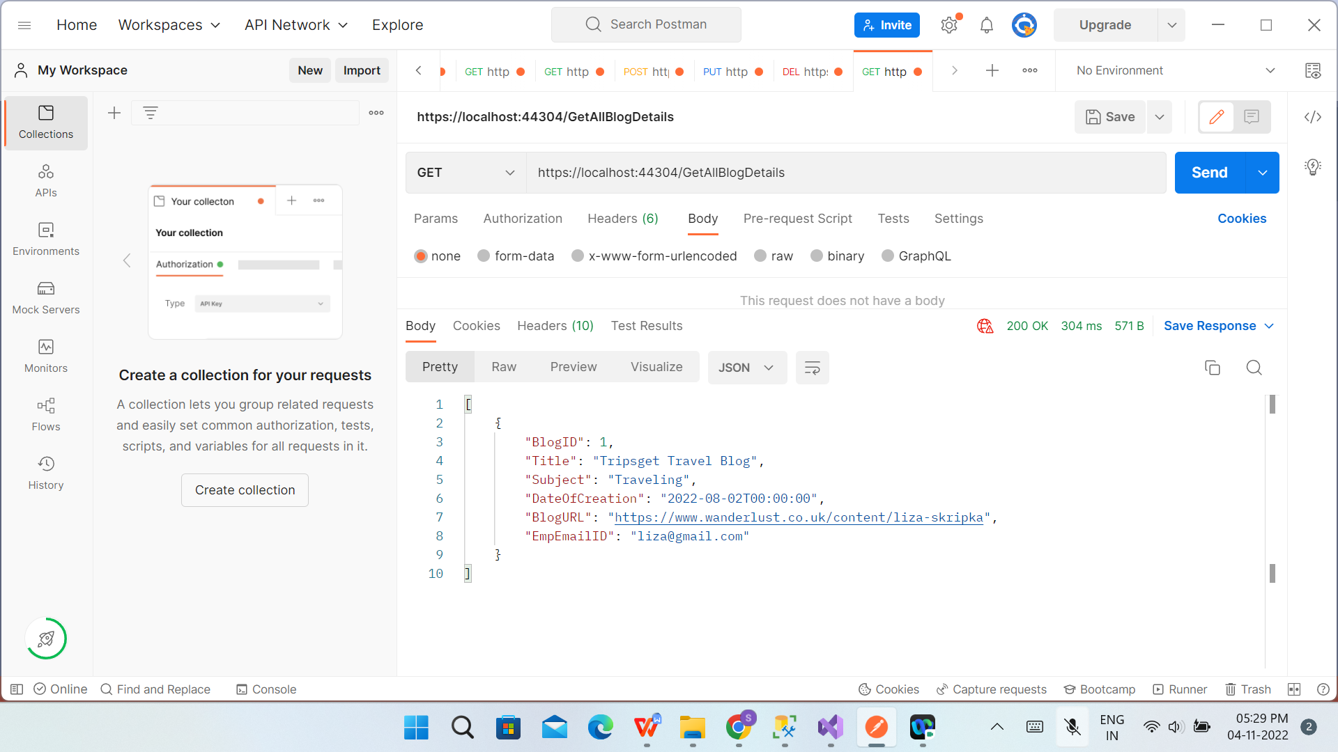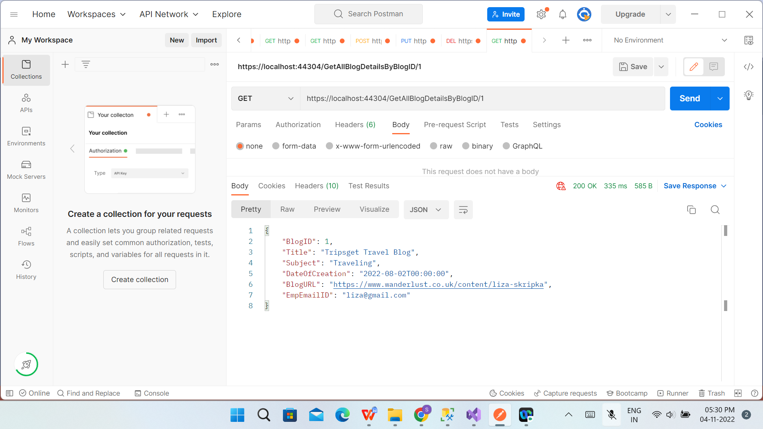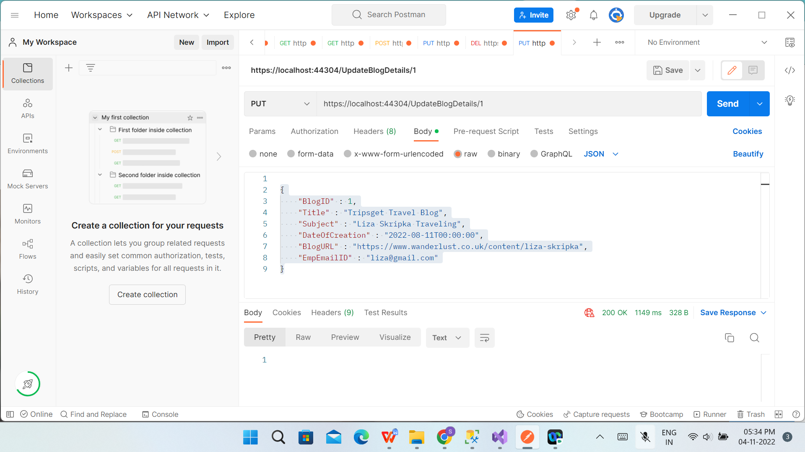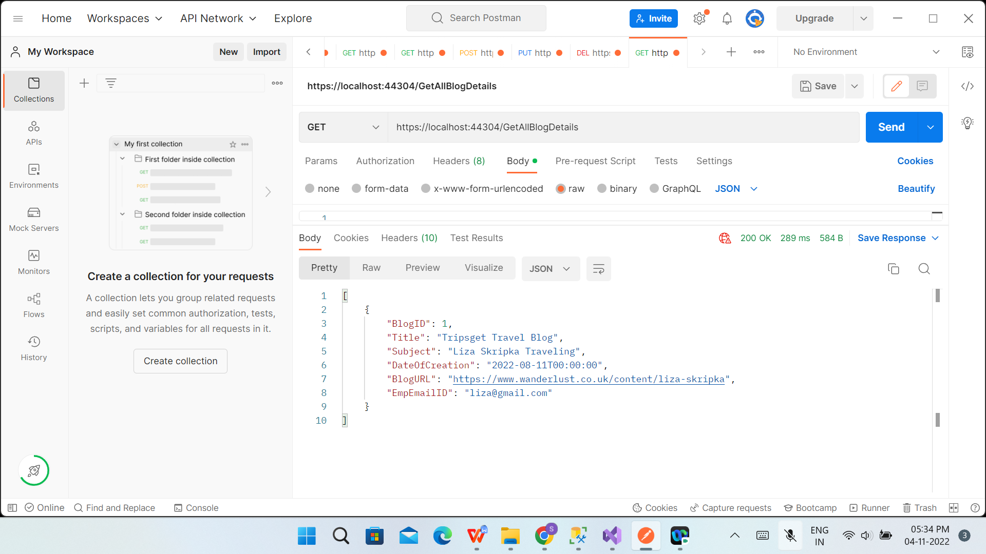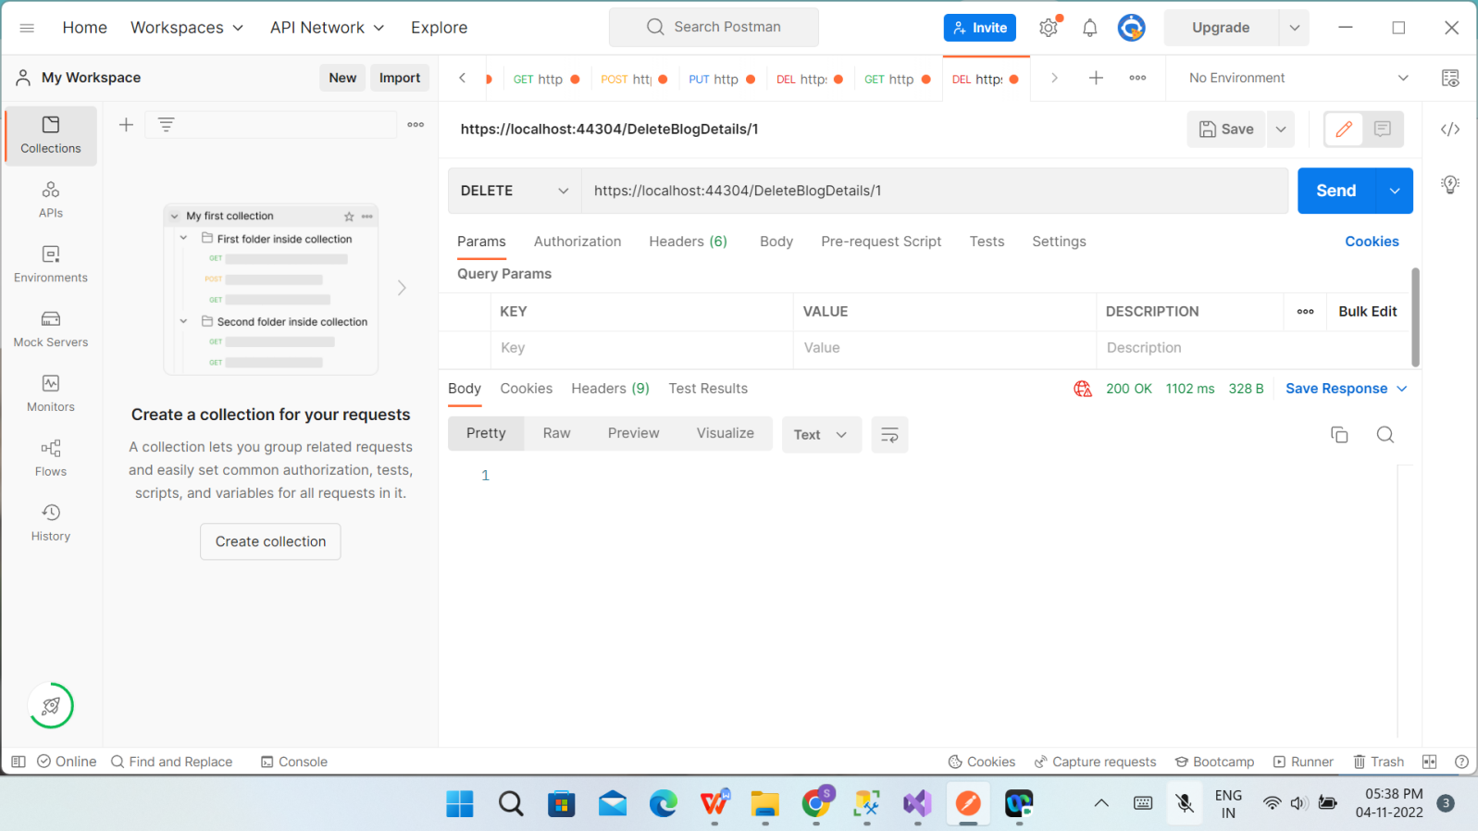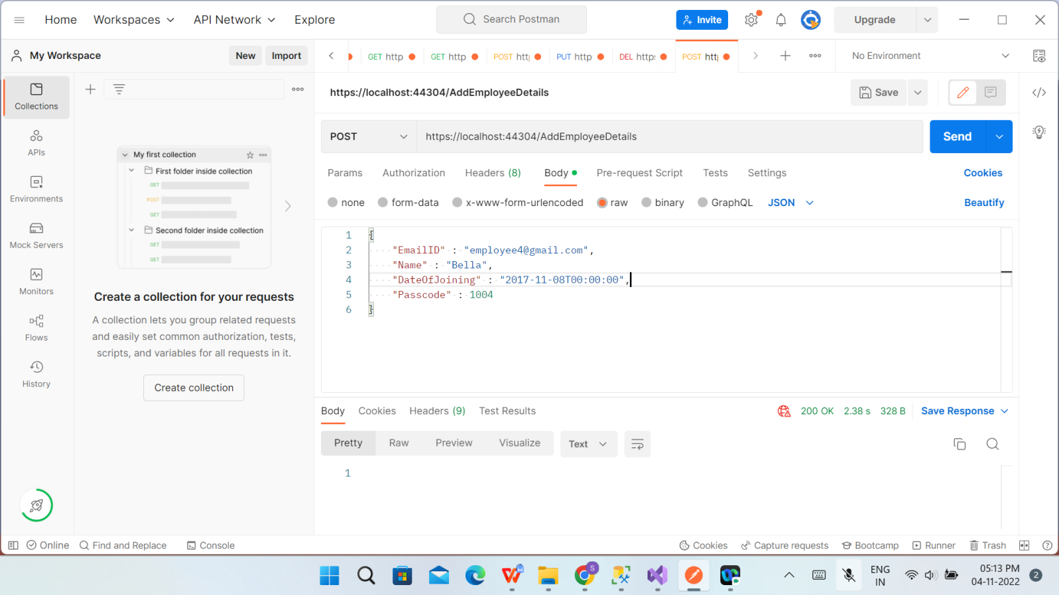

**MVC:**

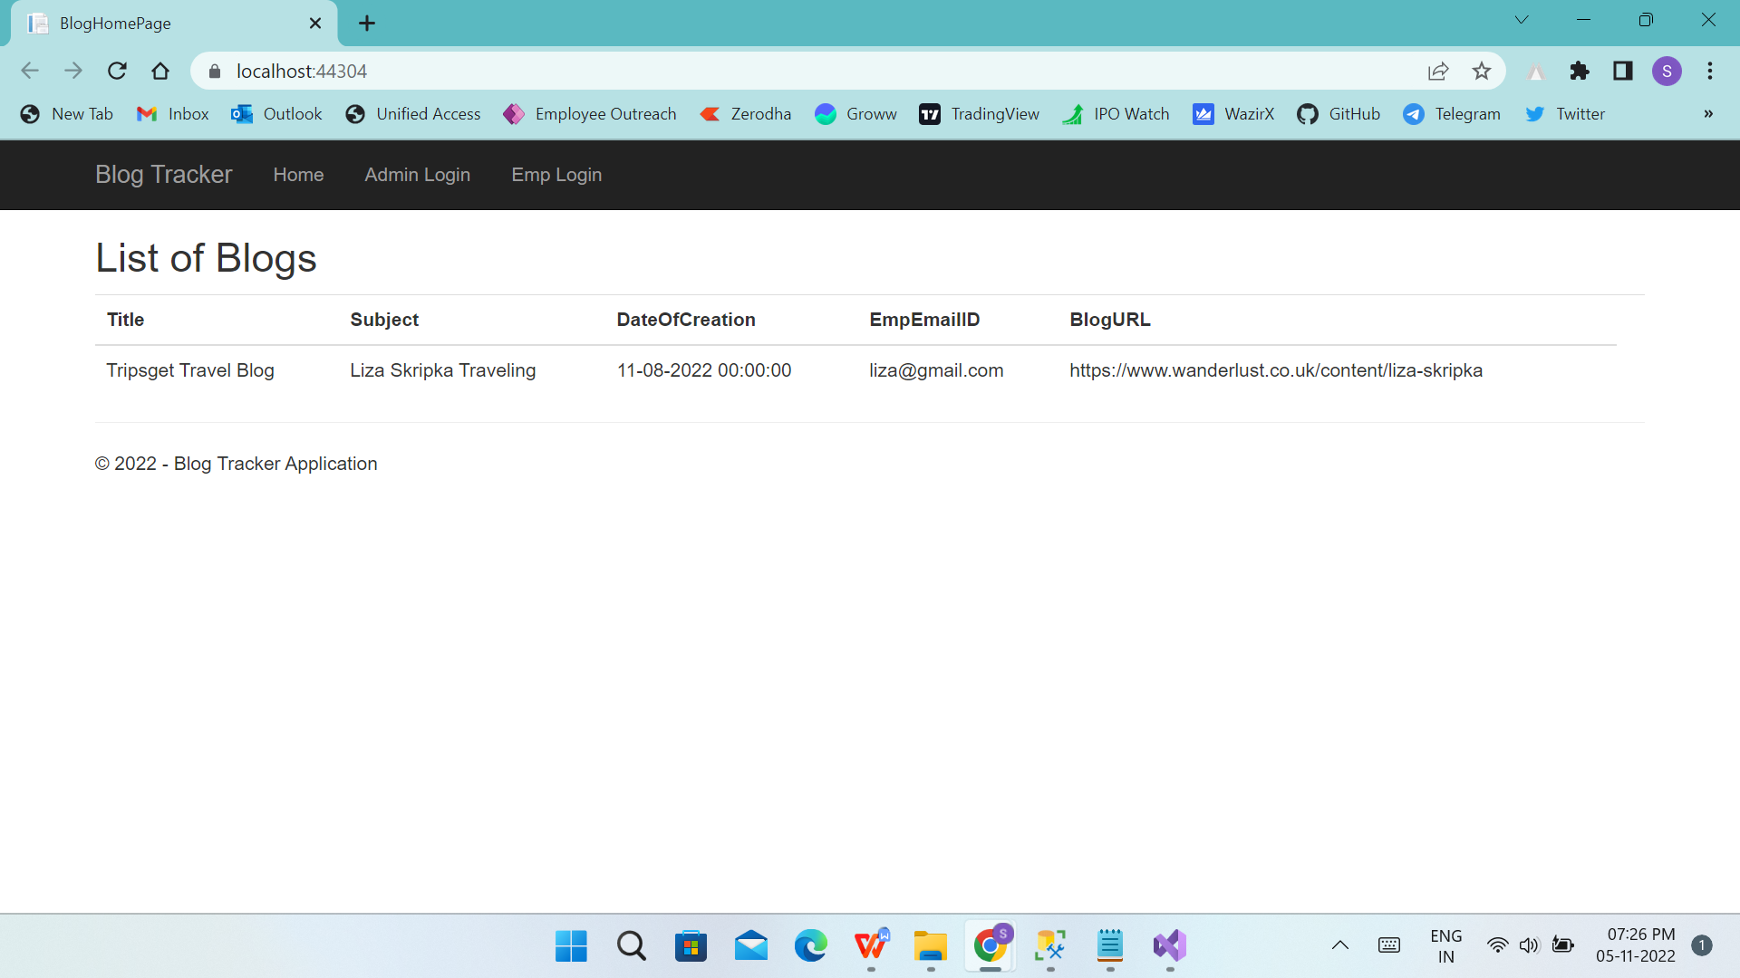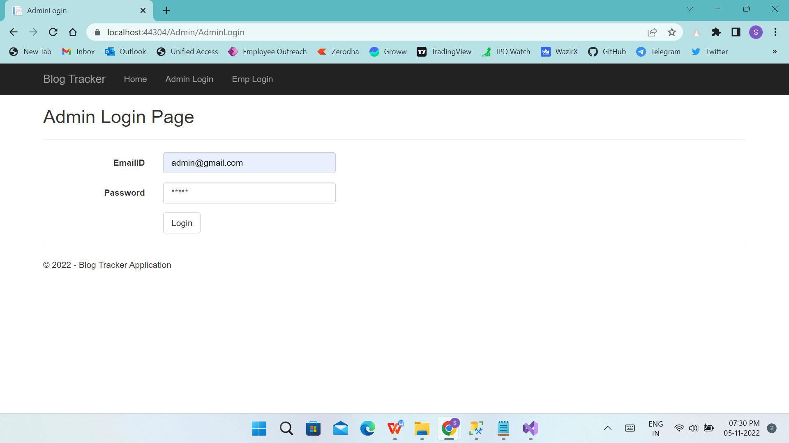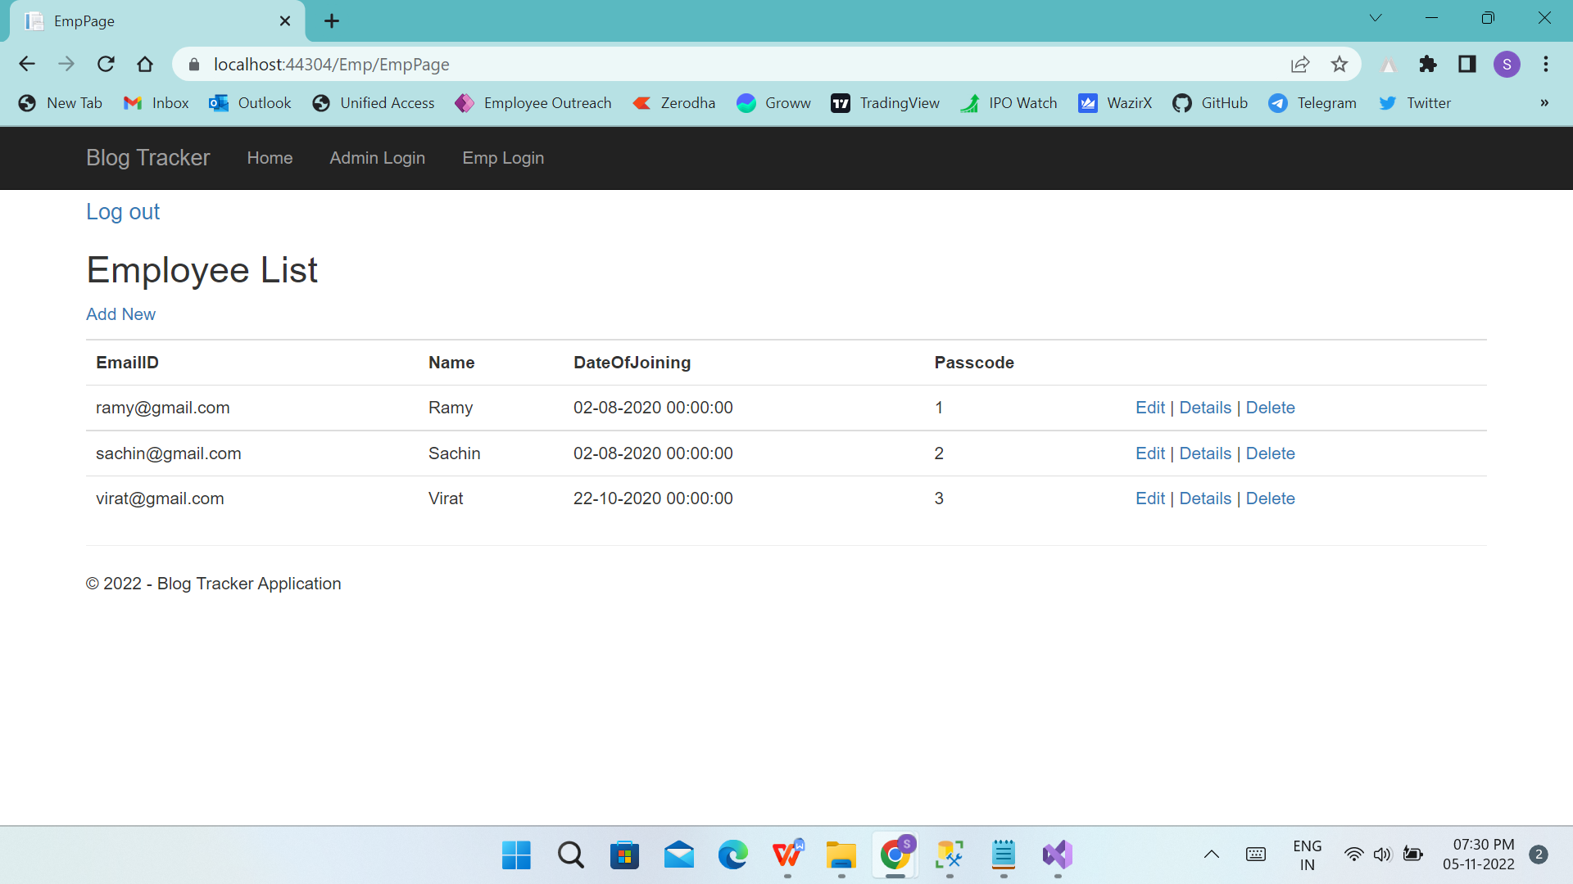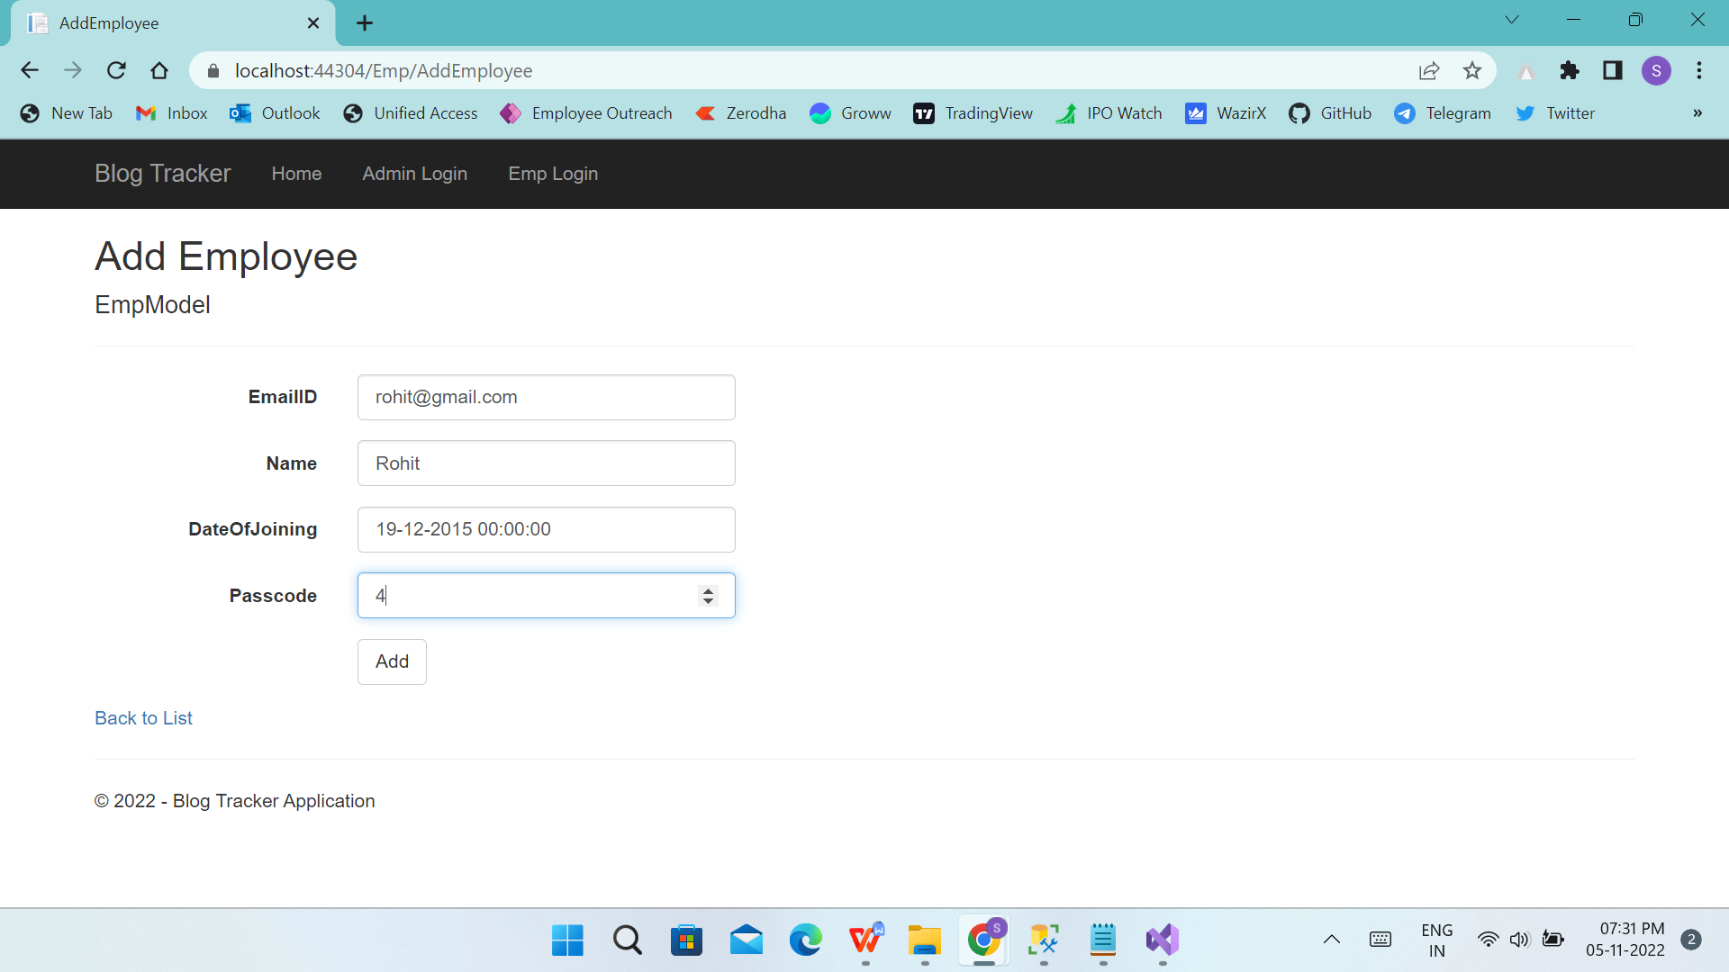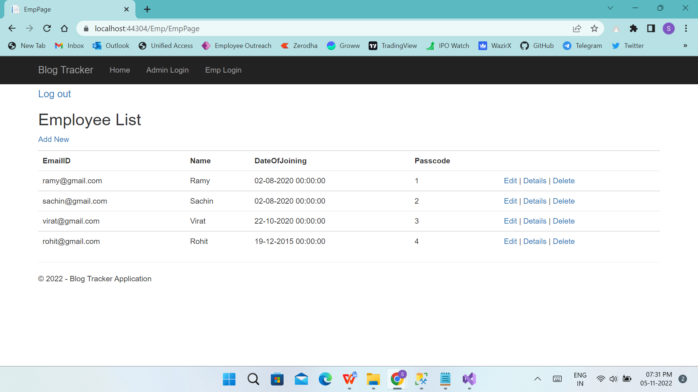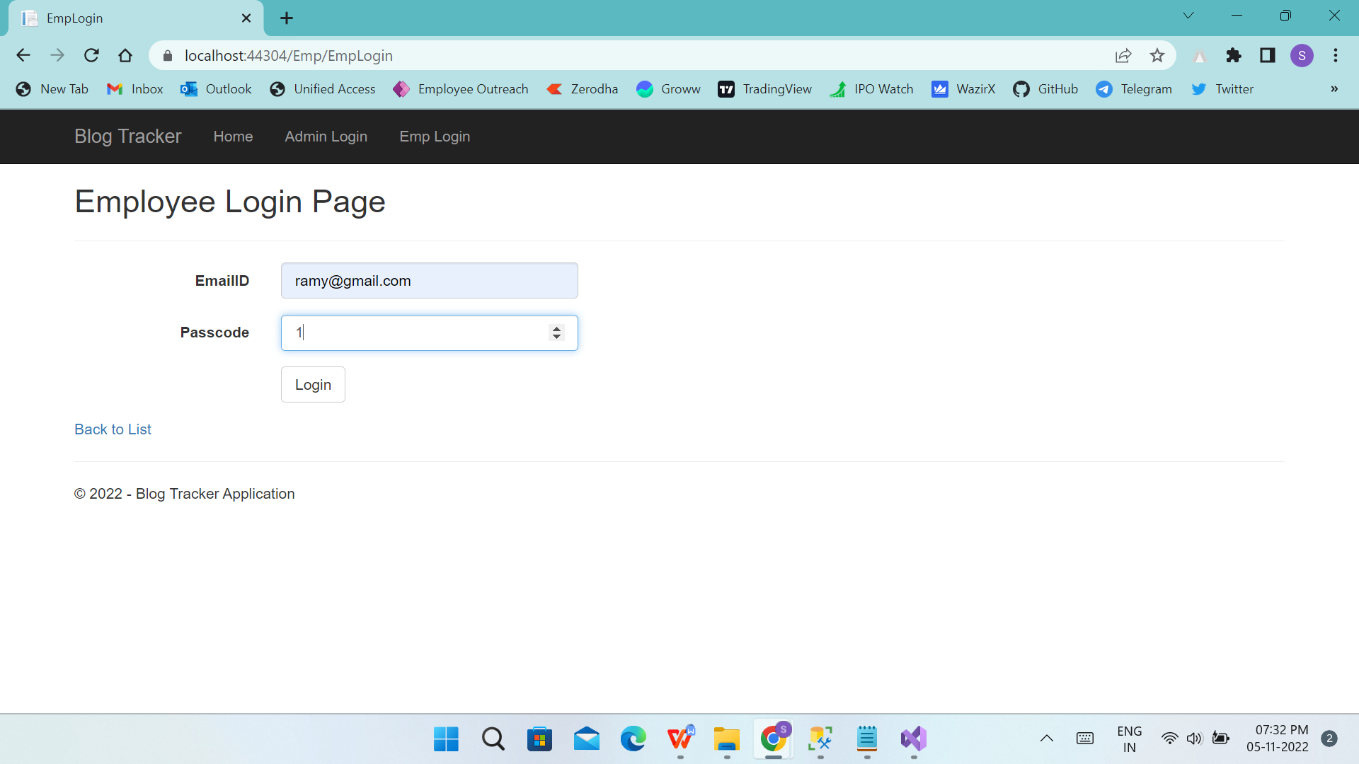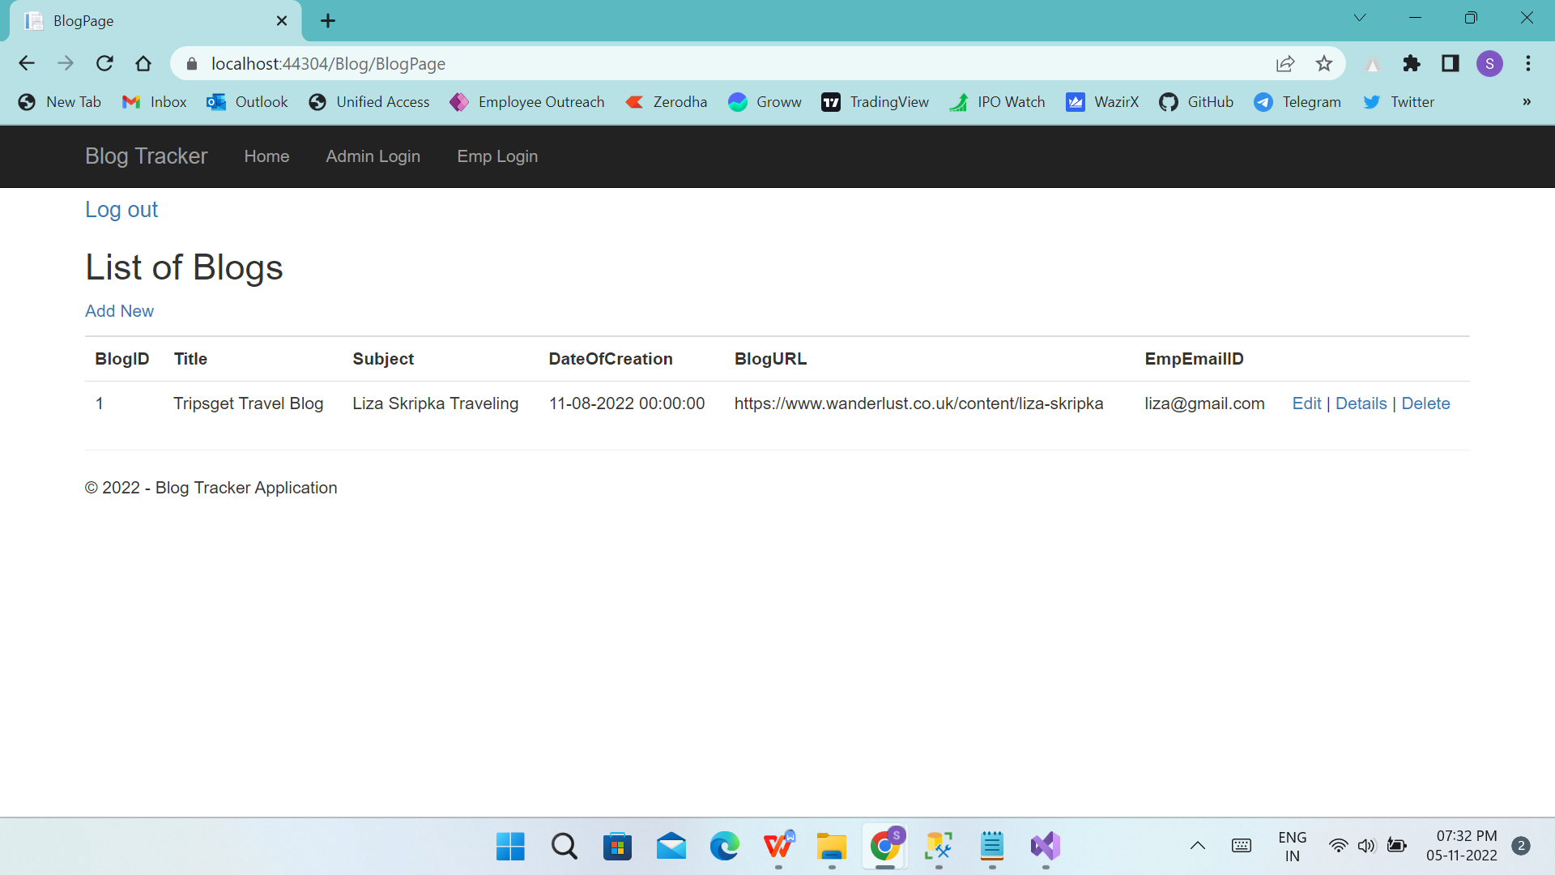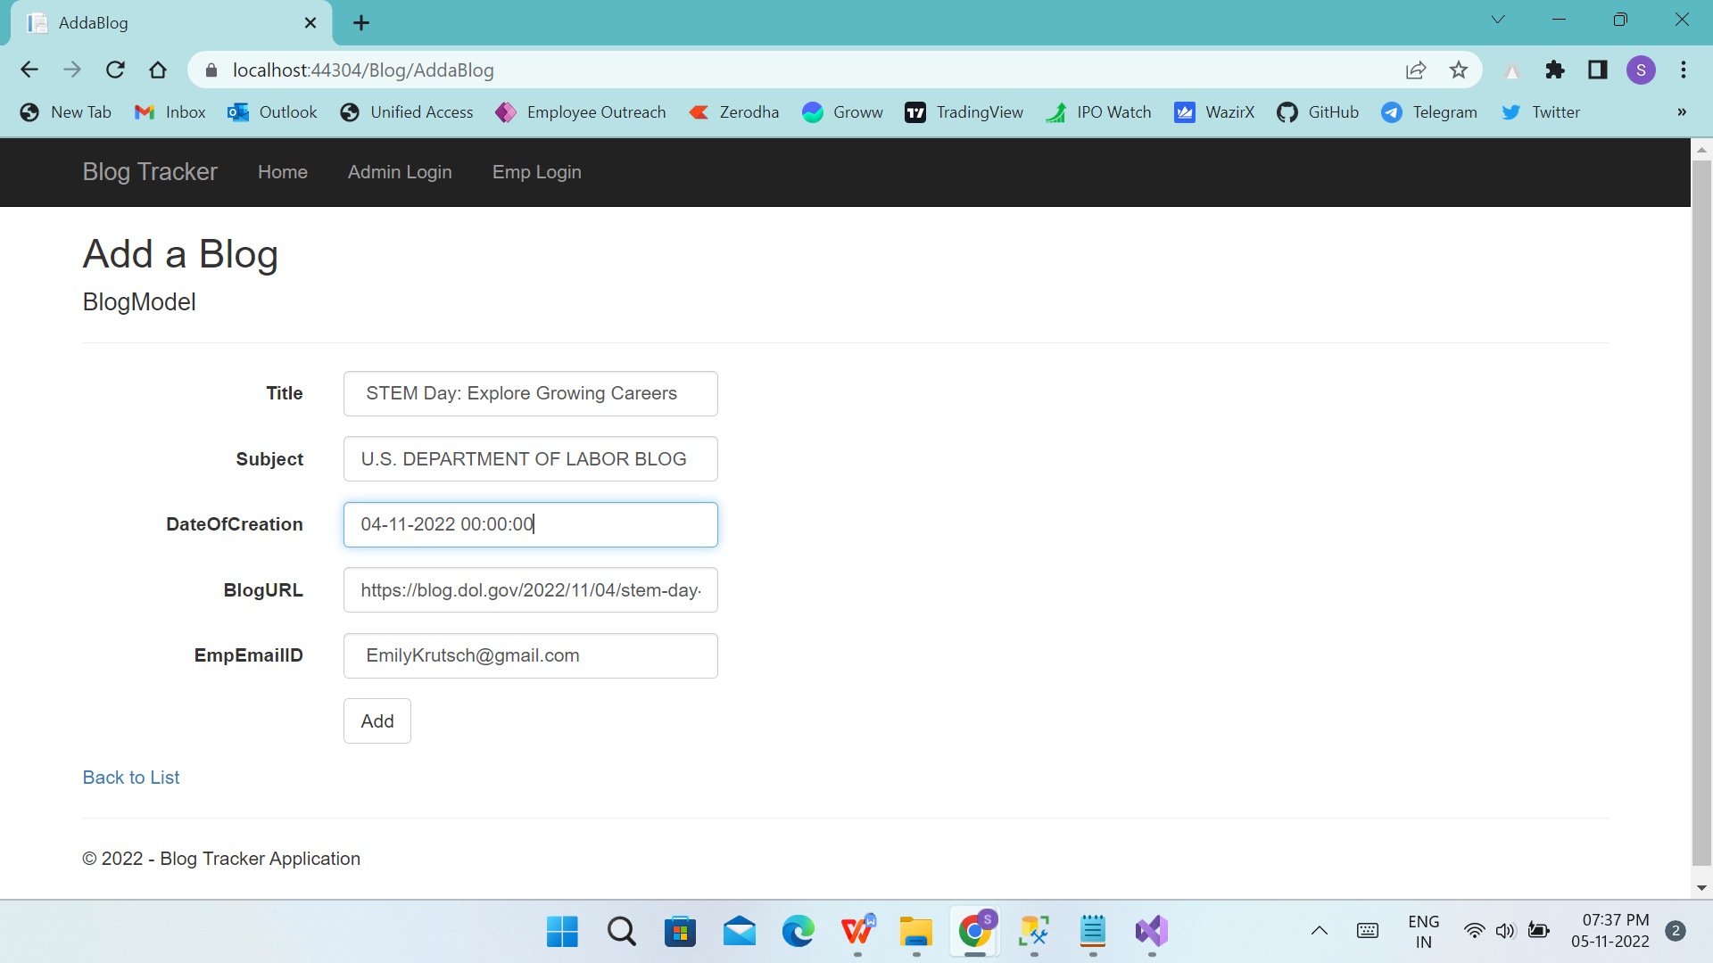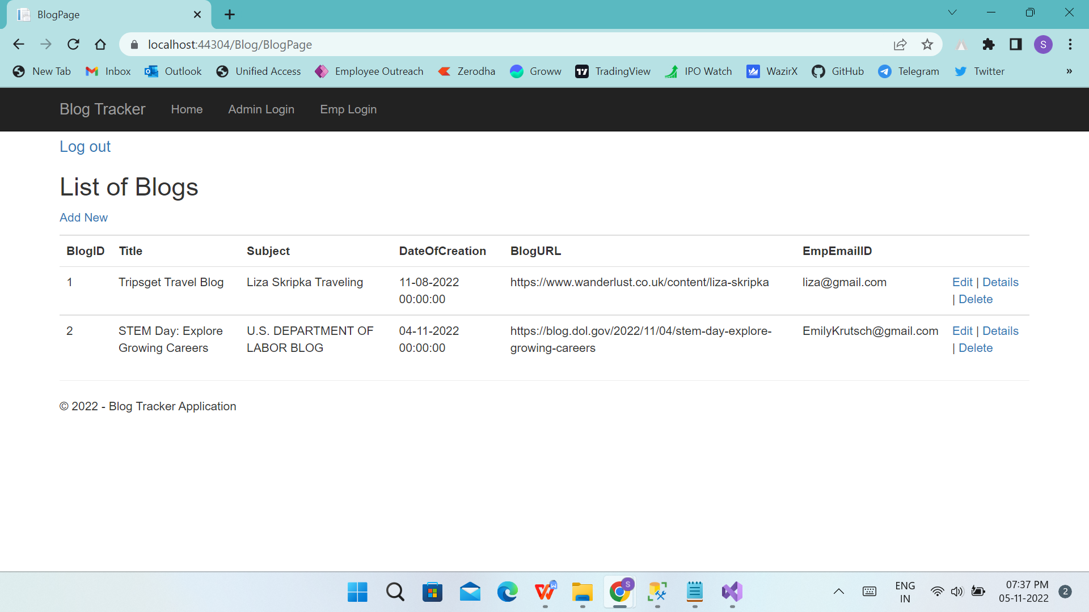

**Docker-**

